Week 4 – Design Concept Development

The property I have chosen to use as a mock marketing campaign is The Skyfall on The Panorama, Tallai.

<https://www.realestate.com.au/property-house-qld-tallai-144914648>

I would like the design to have follow the theme/feel of the property. Luxurious, dark, gold accents, modern.

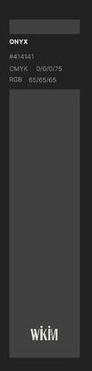02 
01 — 
Studio 
Type 
$41000 
FOR SALE 

Aleja Solidarności 
Śródmieście, Warszawa 
63.11 